August 26th, 2012
Hi
I was not going to write a letter this weekend as many of the letters take a lot of time to write and probably most of the stuff I write about doesn't interest anyone most of the time anyway. Perhaps I will just send a brief letter every two weeks or even reduce it to the occasional e-mail.
I got back OK; no problems with the flights; just a few minutes late arriving in HK. On approaching Newark, we flew parallel to Manhattan and had nice views (though there was some morning mist or air pollution). I was able to identify one or two buildings, including the Statue of Liberty which does seem very small. I would probably not have had such a view had the flight been to New York itself. Then there was an excellent view of Chicago. I was surprised that the downtown/skyscraper area is relatively small set in a huge flat low-rise area that is the rest of the city. I was also impressed with the three airport terminals that I passed through; very clean and efficient. The flight path from Chicago to HK was interesting. It took us north through Canada almost to the North Pole (lots of ice flows and pack ice) before we turned west (not east as I said to you Nadine!) across to Russia and then due south to HK in a giant inverted U. This may not be the shortest route but is probably taken to avoid the strong jet stream winds which blow west to east across the Pacific, so even though it may be further, it is faster. On arrival in HK, I finished the last 2 of the sausage rolls in the bus on the way home.
I am now extremely tired. I have only been able to get about 5 hours of sleep due to body clock still on US time. It is getting a little better now. But I noticed this morning I began to fall asleep again at get-up time probably as this was approaching Boston bed-time. Sometimes I would lie down on the sofa during the day for a short rest only to find out I would immediately fall asleep. I thought I was going to have a rest while in Boston. But that did not eventuate and with the cold (or whatever it was), I am now worse than when I left HK. As Gavin said, I appeared tired and worn out. Exactly!
The first morning back I had to go to supermarket as there was no food here - I don't like leaving food in the fridge when I go away so try to judge it so that all the food is gone just as I leave. Then back to work - even had three phone calls from Singapore to tell me of urgent work. It is hard working with severe jet lag!
I mentioned how travel to the US is a little more difficult due the ESTA requirements. Now China is to introduce tighter entry requirements for tourists. This includes a letter of invitation and a copy of proof of address where one is staying. Apparently this is to control the many illegals who enter China. But it is sure to affect tourism as a number of commentators have already pointed out.
Remember we were talking about the Christopher Robin poems by A A Milne? I looked for the book here but could not find it. But I did find three Winnie the Pooh books.
And about weddings, did you hear of the tragedy in Canada where a bride in her wedding dress slipped and fell into a river? The heavy wedding dress quickly became saturated with water and dragged her under, drowning her. See:
http://www.huffingtonpost.ca/2012/08/24/new-bride-quebec-drowning_n_1828839.html?icid=maing-grid7%7Cmain5%7Cdl1%7Csec1_lnk2%26pLid%3D197020
I heard on the news a few minutes ago that Neil Armstrong died. An ice-cool calm guy he was if ever there was one, an attribute that enabled Apollo 11 to land safely on the moon with less that 30 seconds of fuel remaining due to the need to search for a suitable landing spot. His death was due to heart problems. I remember him commenting later in his life on why he did not exercise that much. He believed that the heart only beat a certain umber of times and that using them all up when it beats faster during exercise, was actually shortening one's life! He ignored the fact that a fit heart actually beats more slowly while not exercising.
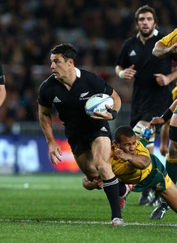
There was the second round of the Southern hemisphere Rugby tests. As Argentina is now included, the name of the tournament has been changed to the “Rugby Championship”. NZ had their second win over Australia winning 22-0 with Dan Carter (pic) getting 17 points. Argentina and SA had a 16-all draw.
That's it.
Cheers

August 26th, 2007
Hi
Not that much to write about this week; the only lines in my diary related to exercise!
The Netscape mail has out of action for a day or so (I note the same thing happened this time last year). They said there was a problem but I think it was just to make slight changes to the format.
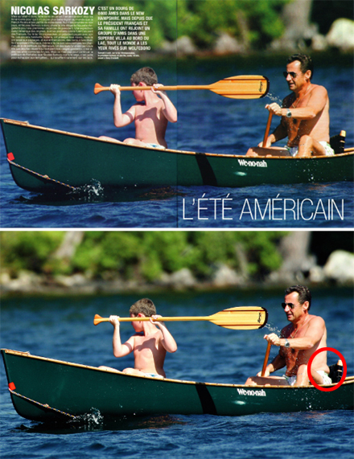
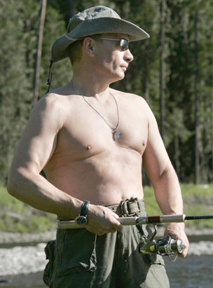
The only thing that interested me during the week were the reports about the French and Russian presidents who were photographed with bare torsos while on holiday. Apparently, the original picture of Sarkozy was touched up before being published to remove a layer of fat around his waist. Putin however was quite different; for a 54-year-old he is well built and his picture went over well in Russia. It was also printed on the front page of a newspaper with arrows pointing to each set of muscles and a step-by-step guide on exercises to do to get a body like the president’s.
That’s about it for this week.
Cheers

